September Newsletter

**September 10, 2012**

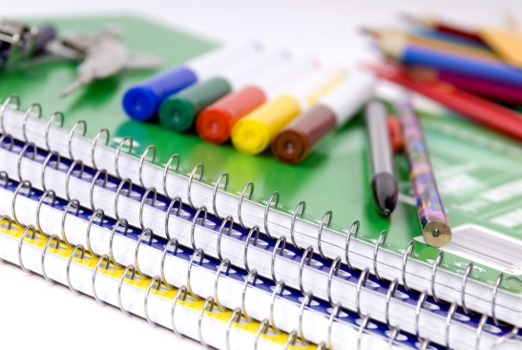

Dear parents and guardians,

I will be sending monthly newsletters to inform you OF WHAT we are working on in our classroom.

We will be working on the following units:

Math – Place value

**C:\Users\2003742\AppData\Local\Microsoft\Windows\Temporary Internet Files\Content.IE5\9TV989BA\MC900435987[1].wmf**

Reading – we will working on metacognition (thinking about your thinking when read ) 

Social studies – native americans

**C:\Users\2003742\AppData\Local\Microsoft\Windows\Temporary Internet Files\Content.IE5\9TV989BA\MC900150097[1].wmf**

writing-informative essays on native americans



**School supplies**

**Parents and guardians,**

**it is imperative that you get your children school supplies for those that haven’t.**

**Listed below are supplies that your child needs if they don’t already have them:**

**Plastic folders with pockets and prongs (red, blue, yellow, green, and orange. Along with the plastic folders students will need a red, green, and blue notebook.**

**red: writing**

**blue: math**

**green: social studies and reading**

**yellow: homework**

**orange: bellwork**

**If you have any questions concerning this information please call me at home or school. my home number is 585-747-8398.**

**#5 School 585-325-2255.**

**Thank you,**

**Mrs. Jordan**

**special thanks,**

**i would like to thank all the parents who have been communicating and signing planners daily.**

**reminders**

**please make sure planners are signed daily**.



.